**Work breakdown structure and Gantt, PERT/CPM CHART**

In order to ensure a systematic and comprehensive approach to the development of the innovative coffee and ‘selit’ exporting system, a well-structured Work Breakdown Structure (WBS) has been devised. This WBS serves as a foundational framework, delineating the key tasks and activities essential for the successful implementation of the system. By breaking down the project into manageable components, this structure facilitates a clear understanding of the project's scope and enables efficient planning, execution, and monitoring of tasks at each stage. The following WBS outlines the hierarchical decomposition of the project phases, providing a structured overview of the various tasks and their interdependencies in the journey toward establishing a seamless and transparent coffee and ‘selit’ exporting system.

1. **Requirement Analysis Phase** 
   * Identify key stakeholders
   * Gather requirements from exporters and farmers
   * Analyze challenges in the coffee and ‘selit’ exporting system
2. **System Design Phase** 
   * Design user interface for exporters and farmers
   * Develop farmer exporter bridging system architecture
   * Determine data structures and protocols for transactions
3. **Development Phase**
   * Implement the farmer exporter bridging system infrastructure
   * Integrate secure transaction protocols
   * Create user-friendly (specially farmer friendly) interface for the system
   * Conduct testing and debugging for the system
4. **Deployment Phase**
   * Plan the system deployment strategy
   * Execute the deployment plan
   * Conduct a pilot test for the system
5. **Training and Support Phase**
   * Provide comprehensive training for system users
   * Establish a support system for users
6. **Evaluation and Improvement Phase**
   * Collect feedback from stakeholders
   * Analyze the system's performance
   * Identify areas for system improvement
   * Implement necessary updates and upgrades

**Work breakdown structure**

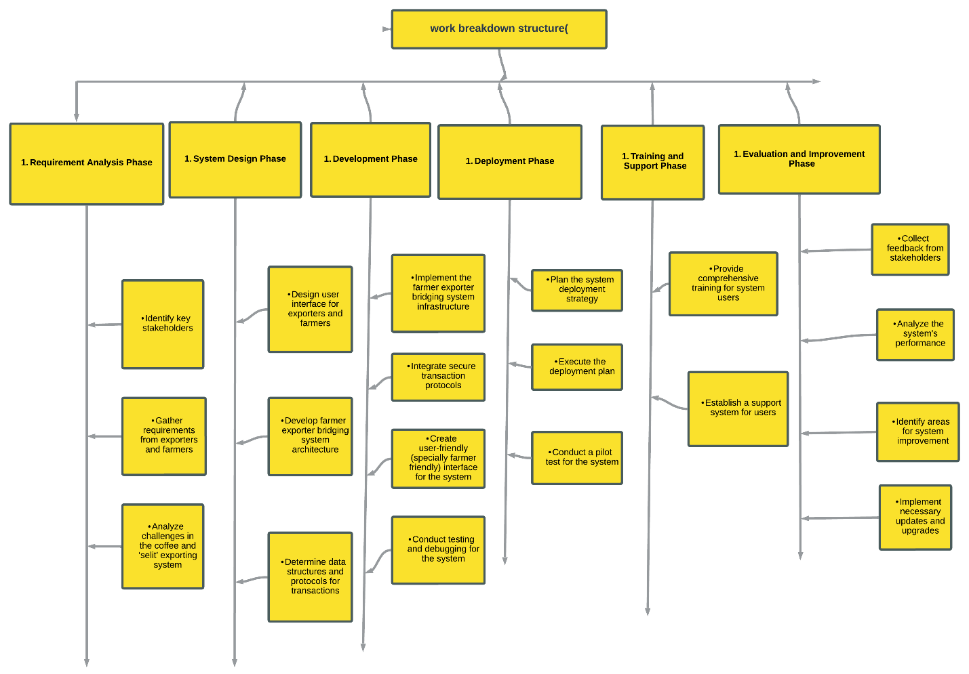

<https://lucid.app/lucidchart/58e950fd-3a6a-4863-9bed-6806ff9595e2/edit?viewport_loc=-4078%2C-1236%2C8368%2C3720%2C0_0&invitationId=inv_f7046f72-456a-40d5-87b8-5566dac926e3>

**Gantt Chart**

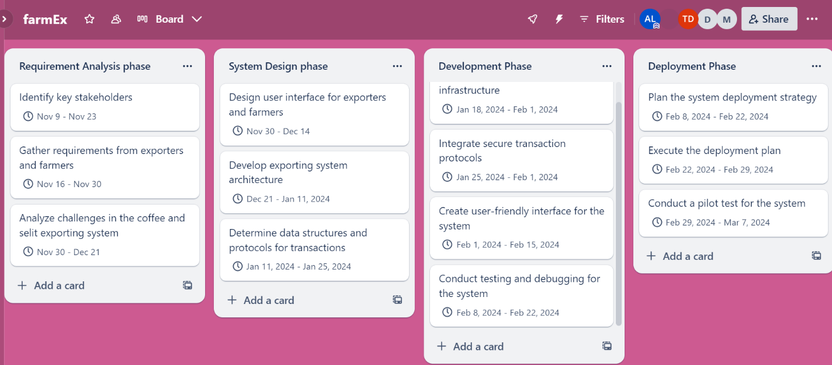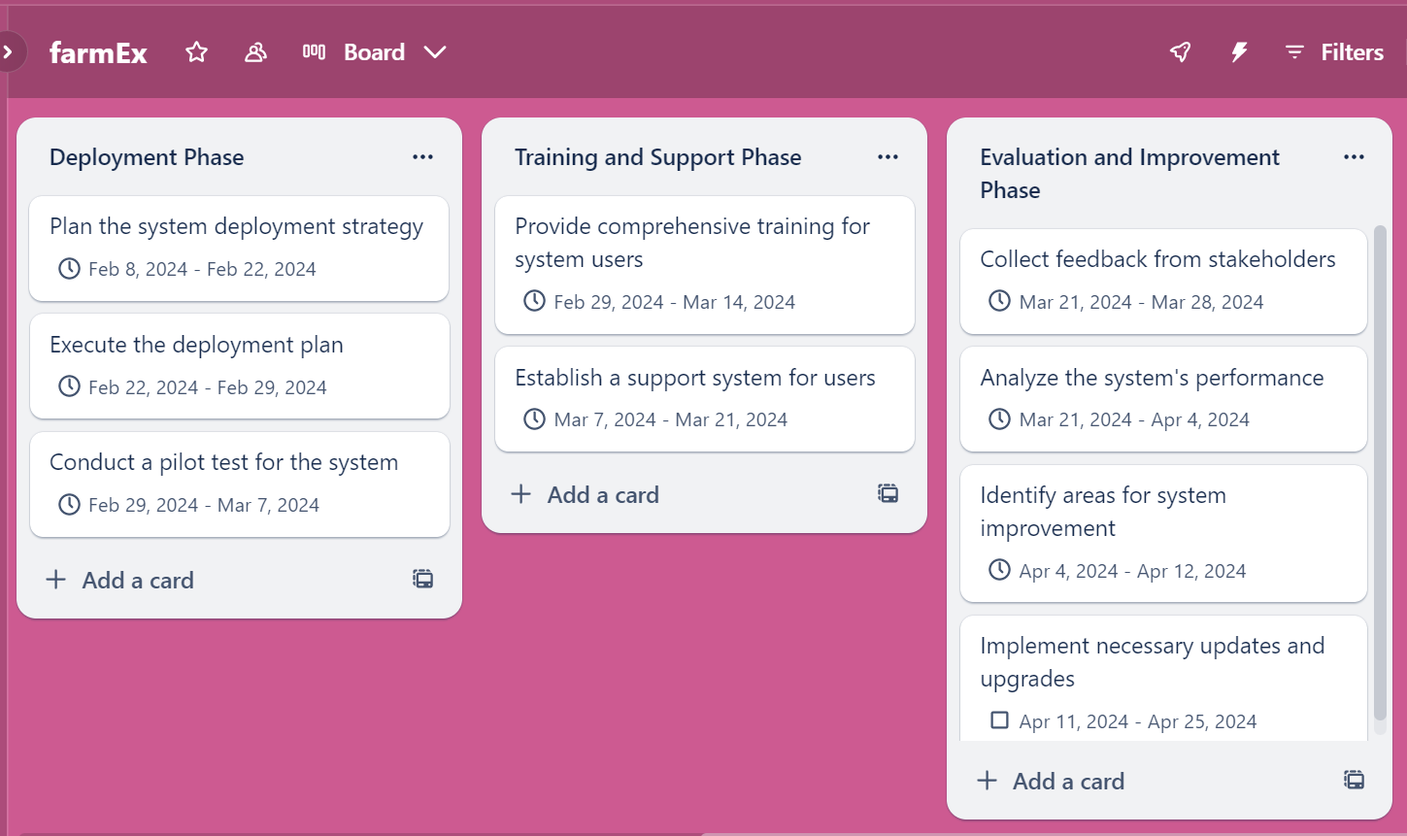

<https://trello.com/invite/b/5izQbpTp/ATTI1ad4a3eeeaec3ff80eabf4b5ad617c5aE93DFE93/farmex>

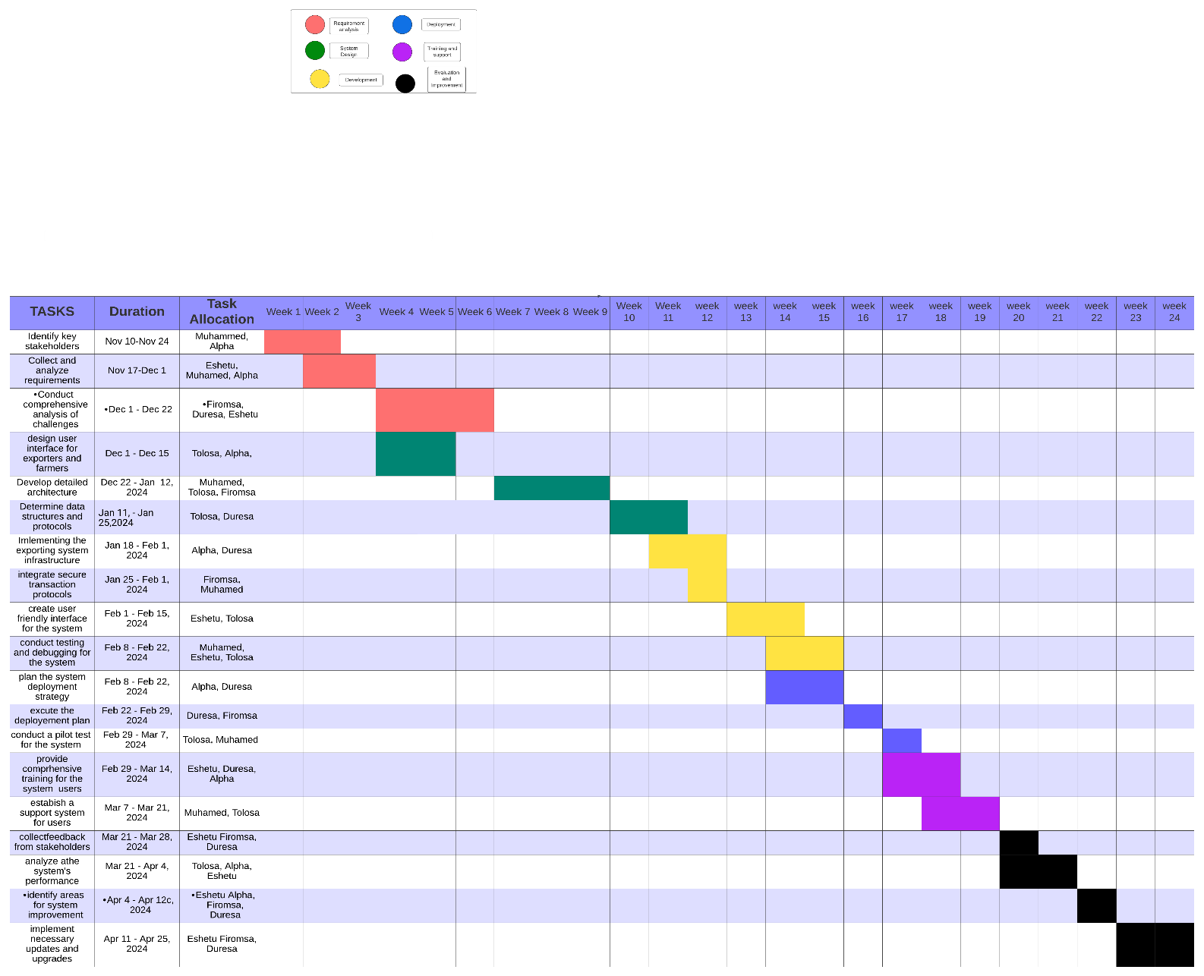

<https://lucid.app/lucidchart/58b865da-47a0-4b17-ad39-50e5461c9e5b/edit?viewport_loc=-2656%2C-1747%2C4080%2C1707%2C0_0&invitationId=inv_a53f88d2-2edb-4226-9142-9ae683f54237>

**PERT/CPM CHART**

|  |  |  |  |
| --- | --- | --- | --- |
|  |  | Estimated | Dependencies |
|  |  | Duration |  |
| Activity | Description | (Days) | predecessor |
|  | Identify key stakeholders | 14 | none |
|  | Gather requirements from exporters and farmers | 14 | A |
|  | Analyze challenges in the coffee exporting system | 21 | B |
|  | Design user interface for exporters and farmers | 15 | B, |
|  | Develop exporting system architecture | 21 | C, D |
|  | Determine data structures and protocols for transactions | 14 | E |
|  | Implement the exporting system infrastructure | 14 | F |
|  | Integrate secure transaction protocols | 7 | F |
|  | Create user-friendly interface for the system | 14 | F |
|  | Conduct testing and debugging for the system | 14 | H |
|  | Plan the system deployment strategy | 14 | H |
|  | Execute the deployment plan | 7 | K |
|  | Conduct a pilot test for the system | 7 | K |
|  | Provide comprehensive training for system users | 15 | G |
|  | Establish a support system for users | 15 | G |
|  | Collect feedback from stakeholders | 7 | M, L |
|  | Analyze the system's performance | 15 | P |
|  | Identify areas for system improvement | 7 | P |
|  | Implement necessary updates and upgrades | 14 | R |

